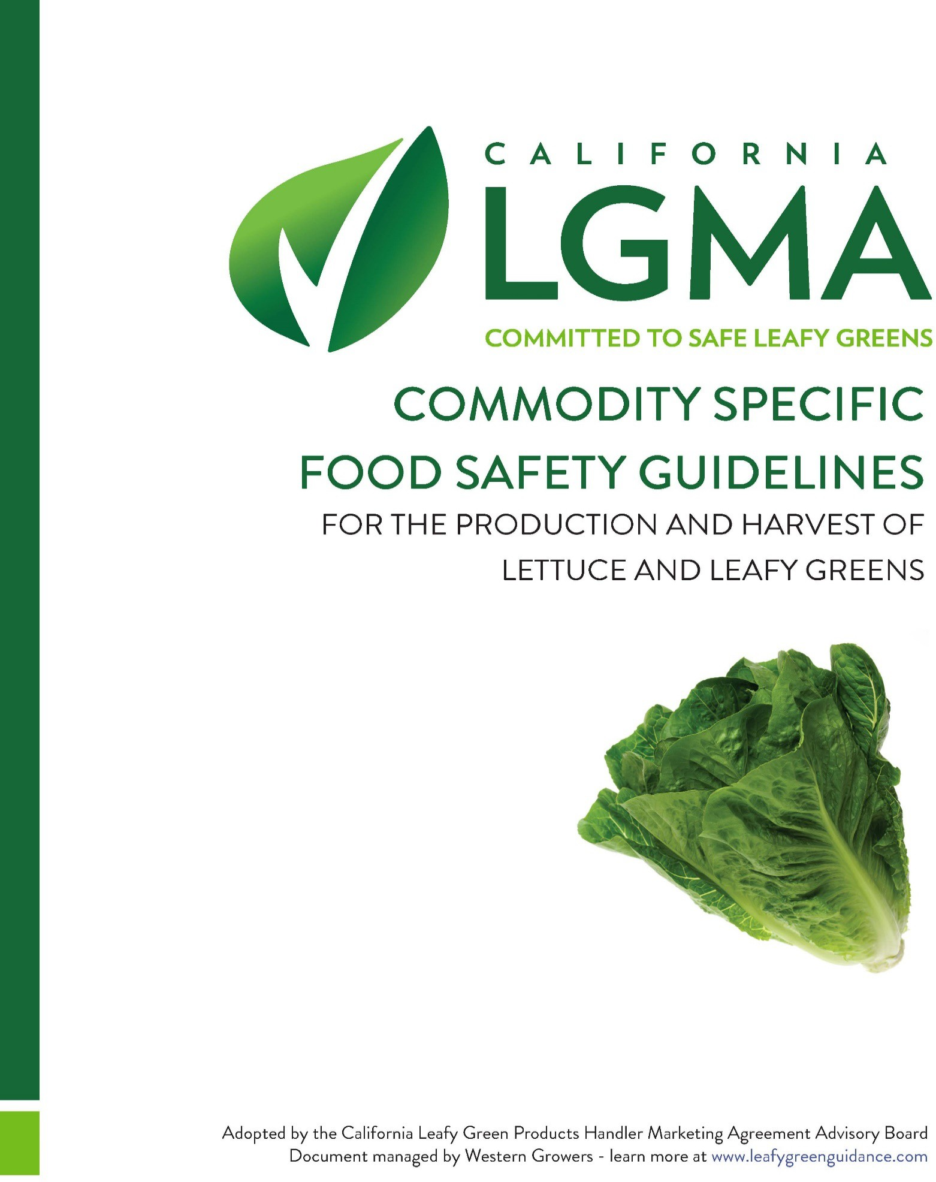

AUGUST 21, 2024

This document supersedes all previously published versions of the Commodity Specific Food Safety Guidelines for the Production and Harvest of Leafy Greens including those dated on or before September 20, 2023.

# 17. ROMAINE TESTING AND DATA ANALYSIS PROGRAM

1. **PERSONNEL QUALIFICATIONS AND TRAINING**
2. **PERSONNEL QUALIFICATIONS AND TRAINING**
3. **PERSONNEL QUALIFICATIONS AND TRAINING**

The purpose of a standardized romaine testing program is to enable the leafy greens industry to learn from individual and aggregated data, which contributes to industry knowledge about current systems and informs on measures to improve programs. The goal of this project is to collect and analyze data along with other potential key learnings from standardized romaine testing over the following time periods:

* Initial period: Oct 1, 2023 – Sept 30, 2025
* Extended period: Oct 1, 2025 – Sept 30, 2027

**Who submits the data:**

LGMA handlers whose romaine undergoes testing will submit those test results using the approved database. Only romaine that is currently being tested, such as for customer and/or regulatory requirements, internal company policies, etc., must be submitted. No additional romaine is required to be tested if a handler member does not have a testing policy in place.

## The Best Practices for Sampling and Testing Are:

The sampling and testing parameters are as follows:

* **Data sources**: Test results for Romaine grown in California
* **Sampling timeline:** < 10 days for pre-harvest or < 24 hours for post-harvest samples
* **Test organisms:** STEC and/or EHEC, *E. coli* O157:H7, *Salmonella*
* **Sampling lot size:** < 10 acres for both a pre-harvested product and/or a company-defined post-harvest product lot for product sampled at any step prior to but not including processing.
* **Sample size:** Minimum 375 g from n = 60 sub-samples *
* **Sampling method:** Information on the sampling pattern to be submitted

*The entire 375-gram sample must be analyzed by the laboratory for both pre-harvest and post-harvest samples.

## The Best Practices for Data Reporting and Analysis Are:

**For every sample** participating California LGMA members will submit data on a quarterly basis including the following information:

* Unique sample ID (as assigned by the laboratory)
* Acres sampled (pre-harvest); or cartons (post-harvest) sampled
* Sampling stage (pre-harvest or post-harvest) **
* Grower
* Ranch
* Commodity and field-packed description (romaine, romaine hearts, top and tail, etc.)†
* Sample date
* Organism tested (STEC and/or EHEC, *E. coli* O157:H7, *Salmonella*)
* Method of reference
* Standardized test result

**Romaine T&L Ranch Form:** The Ranch Form approved by the CA LGMA T&L Data Governance Group will be submitted once a year (at program extension start) or when changes are made to information within the form. This form is to be completed by the handler.

**Romaine T&L Method Verification Form:** Method Verification Form approved by the CA LGMA T&L Data Governance group will be submitted once a year (at program extension start) or when changes are made to the methods reported in the form. This form is to be completed by the grower and the lab performing their testing.

**Root Cause Interview:** Participating CA LGMA members will meet with the program administrators to complete a standardized root cause analysis form for every positive sample submitted.

*\*\*Note: pre-harvest and post-harvest data will be analyzed separately*

†*Baby tender leaf romaine is not included.*